Press Release
2014. 11.20 | Contact Thai Ji (070-7839-5200) / joinus@joinuskorea.org
JOINUS WORLD, Global Multilingual Intellectual for Foreigners in the Era of Multiculture
- Promoting an Affiliation with Law, Medical, Labor Advisory Organizations such as Seoul Global Center and Legal Aid Corporation -

JOINUS WORLD is promoting an affiliation with law, medical, labor advisory organizations such as Seoul Global Center and Legal Aid Corporation.
( Case 1 )
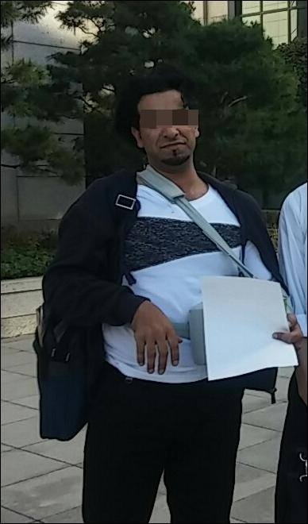
Mr. Khalid, got the hit-and run recently

Mr. Khalid who had been dispatched to work from a Saudi Arabia’s leading oil company, visited Korean police office because recently he got a hit-and-run case at night with six-week medical diagnosis. However, he was at a loss because of communication barrier and furthermore no knowledge of the legal process in Korea, he could not receive any enough service except just several investigations.
He visited the JOINUS WORLD website, multilingual knowledge exchange site that he could know through his companion’s introduction, and he appealed his situation. Ms. Myung-Hee Han, a volunteer in JOINUS WORLD, translated and gave to an advisor attorney Mr. Young-Kwan Cho and returned his counsel result to Mr. Khalid with Ms. Han’s assistant. Everything was going in real time on the website. Mr. Khalid said, he was going well through the proper legal proceedings without major problems, thanks to JOINUS WORLD.

( Case 2 )

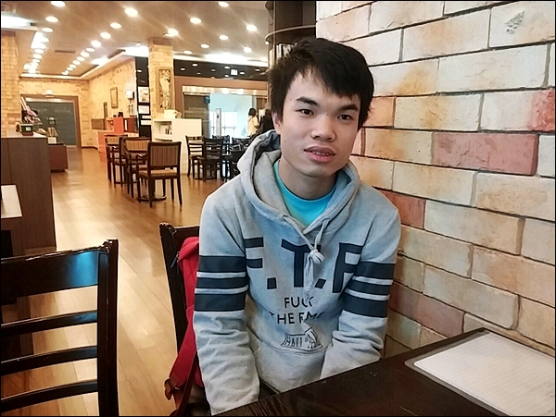
Mr.Thanhcong, Exchange Student from Vietnam

A vietnamese student Mr.Thangcong, residing in Seoul from earlier this year as an exchange university student, had been trouble with wage problem, because he could not receive any his payment for two-month part time works at a courier company during the summer vacation.
He posted his concerns on the JOINUS WORLD website after searching the internet. A volunteer, Mr. Tae-Hwan Ji translated and obtained an advice from the legal advisory council member, Mr. Won-Seok Jung, labor consultant and finally could get the solution clue. Above all, he had many difficulties, because he was only one Vietnam student in his school, he came to say thank to JOINUS WORLD office in person.
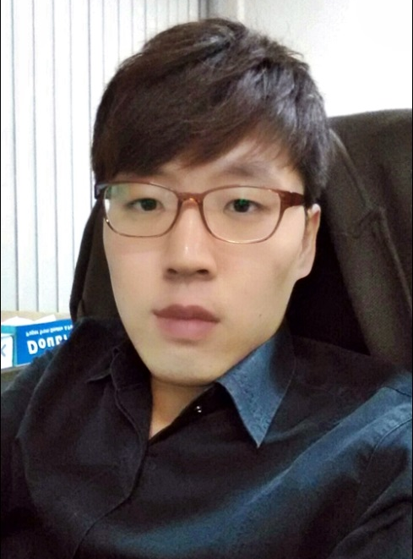
An attorney Mr. Young-Kwan Cho (left) / A labor attorney, Mr. Won-Seok Jung

JOINUS WORLD, these two foreigners used, located in Yangcheon-gu, Seoul Korea, operated by an NGO organization, JOINUS KOREA, is a website for multilingual knowledge exchange and available at the pc or smartphone. Currently the volunteers ​​called Joker, 'borderless language and culture knowledge exchange volunteers' are active with 29 different languages. Anyone can easily join with just email address and can use comfortably as foreigners because of providing more than 20 UI.

Mr. Yong-Seok Seo, an executive director in JOINUS KOREA, said that until now the questions were within the level of voluntary activities to response them, but recently many requests need more expert knowledge such as law and medical consultation beyond the level of simple language translation. Accordingly, JOINUS WORLD is promoting the alliances with such as Legal Aid Corporation and Seoul Global Center which can provide their advisory service.
He said, as time goes on, Korea is becoming increasingly aging society with low birthrate engaging a prospective multicultural era, JOINUS KOREA is trying to be a model among the academic-industrial partnership and private-public joint cooperation to be another growth engine of the Republic of Korea, as a peaceful fusion and harmony with many foreigners flux. .

JOINUS KOREA officer showed its future hope that JOINUS WORLD provides a field of knowledge communication in Korean multicultural society as a non-profit organization website service like Wikimedia foundation, implementing the diplomatic activities mediated knowledge through the affiliation with many related agencies.
- end -

